**Task 1:**

Creating path - /home/acadgild/hadoop

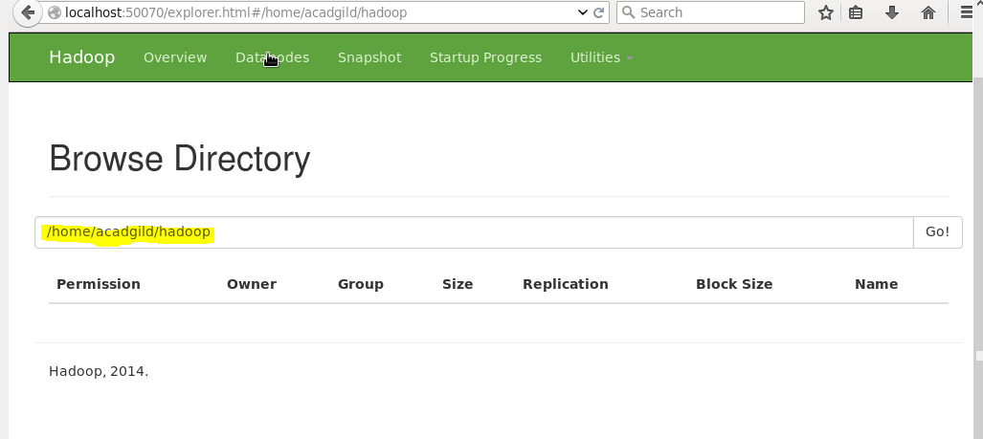

**Task 2:**

